CIS7 Unit 11 In-Class Assignment: Cryptograph and Modular Arithmetic
This assignment is based on Chapter 5 concepts. Refer to textbook and Chapter 5 notes to complete the below exercises.
- Based on Caesar Cipher, a substitution cipher, encrypt the following messages by shifting the letters 7 places to the right. Input the shifted characters in the 2nd row of each table, then encrypt the message.
- COMPUTER SCIENCE
A | B | C | D | E | F | G | H | I | J | K | L | M | N | O | P | Q | R | S | T | U | V | W | X | Y | Z
 |  | V |  | X |  |  |  | B |  |  |  | F |  | H | I |  | K | L
VHFINMXK LVBXGVX
- KEEPING SECRETS
A | B | C | D | E | F | G | H | I | J | K | L | M | N | O | P | Q | R | S | T | U | V | W | X | Y | Z
 |  | V |  | X |  |  |  | B |  | D |  |  |  |  | I |  | K | L | M
DXXIBGZ LXVKXML
- CHANGE THE WORLD
A | B | C | D | E | F | G | H | I | J | K | L | M | N | O | P | Q | R | S | T | U | V | W | X | Y | Z
T |  | V | W | X |  | Z | A |  |  |  | E |  | G | H |  |  | K |  | M |  |  | P
VATGZX MAX PHKEW
- Using the same technique, decrypt the following messages using Caesar Cipher by shifting the letters 7 places to the left. Input the shifted characters in the 2nd row of each table, then decrypt the message.

- ZBJJLZZMBS WYVALJAPVU
A | B | C | D | E | F | G | H | I | J | K | L | M | N | O | P | Q | R | S | T | U | V | W | X | Y | Z
T | U | V | W | X | Y | Z | A | B | C | D | E | F | G | H | I | J | K | L | M | N | O | P | Q | R | S
SUCCESSFUL PROTECTION
- LUJVKPUN ALEA
A | B | C | D | E | F | G | H | I | J | K | L | M | N | O | P | Q | R | S | T | U | V | W | X | Y | Z
T | U | V | W | X | Y | Z | A | B | C | D | E | F | G | H | I | J | K | L | M | N | O | P | Q | R | S
ENCODING TEXT
- Encode the below messages using the provided table using double digits from 00 - 25, as described in Chapter 5. We will use 26 for a space, 27 for a period and 28 for a comma.
- TAKE ON CHALLENGES

A | B | C | D | E | F | G | H | I | J | K | L | M
0 | 1 | 2 | 3 | 4 | 5 | 6 | 7 | 8 | 9 | 10 | 11 | 12
N | O | P | Q | R | S | T | U | V | W | X | Y | Z
13 | 14 | 15 | 16 | 17 | 18 | 19 | 20 | 21 | 22 | 23 | 24 | 25
19, 0, 10, 4, 26, 14, 13, 26, 2, 7, 0, 11, 11, 4, 13, 4, 6, 4, 18
- TOP SECRET
A | B | C | D | E | F | G | H | I | J | K | L | M
0 | 1 | 2 | 3 | 4 | 5 | 6 | 7 | 8 | 9 | 10 | 11 | 12
N | O | P | Q | R | S | T | U | V | W | X | Y | Z
13 | 14 | 15 | 16 | 17 | 18 | 19 | 20 | 21 | 22 | 23 | 24 | 25
19, 14, 15, 26, 18, 4, 2, 17, 4, 19
- Describe the One-Time Pad Ciphering method.
The two parties that want to communicate pre share a key that is the length of the message being sent. This is the pad. We then take every character in the message and xor it with the corresponding character in the pad. The resulting message is our cipher-text.
- Using Vigenere cipher and determine the encrypted message for the below phrases and keyword?
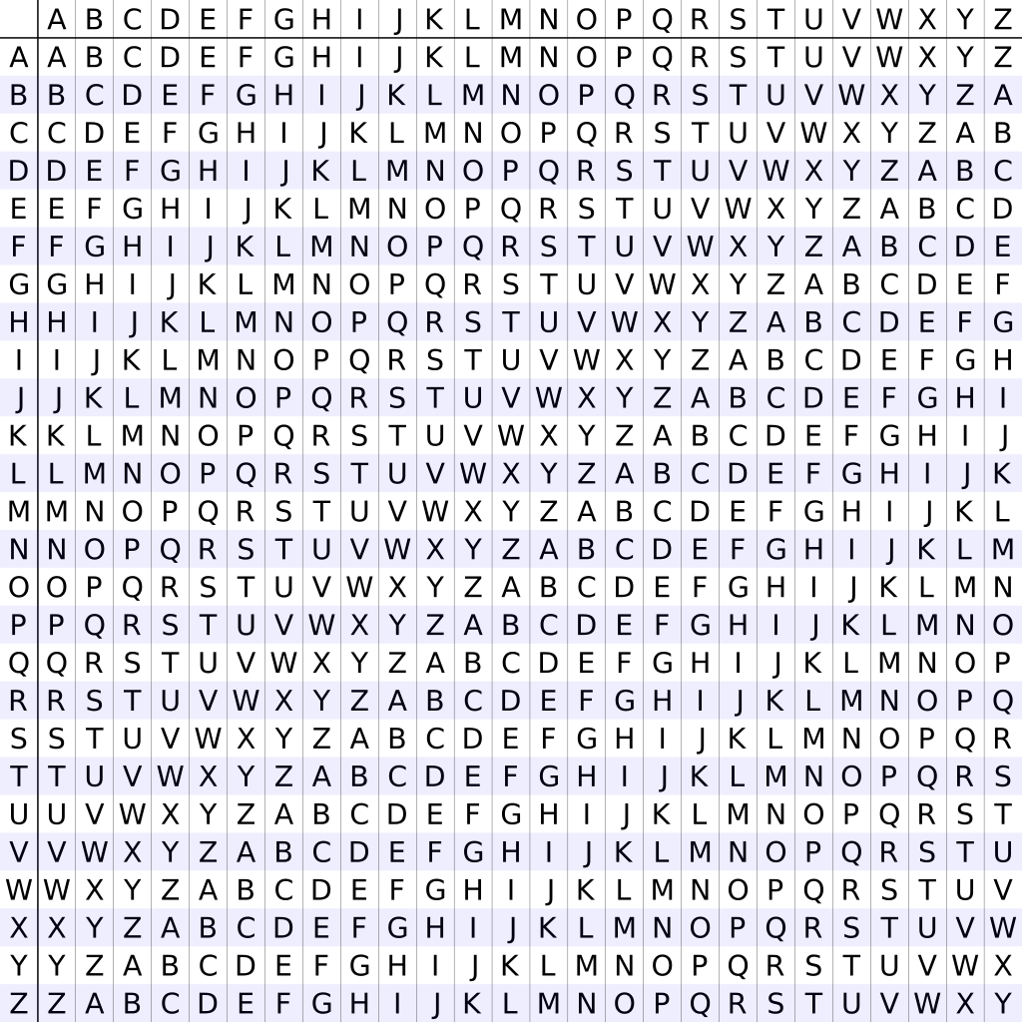
- PLAIN TEXT: GRADUATIONISNEAR
KEY: EARN
CIPHER: KRRQYAKVSNZFRERE

- PLAIN TEXT: MASKPLAINTEXT
KEY: SECRET
CIPHER: EEUBTESMPKIQL

- Refer to Chapter 5 mod function definition, examples and solve for the following problems:
- 80 mod 3
2
- 120 mod 14
8
- 975 mod 2
1
- 461 mod 3
2
- 726 mod 25
1
- Given (A + B) mod C = (A mod C + B mod C) mod C , solve the following problems:

- (15+16) mod 7

(15 mod 7 + 16 mod 7) mod 7 = 3
- (10 + 29) mod 4
(10 mod 4 + 29 mod 4) mod 4 = 4
- (19 + 23) mod 8
(19 mod 8 + 23 mod 8) mod 8 = 2
- Given (A * B) mod C = (A mod C * B mod C) mod C, solve the following problems:
- (18*11) mod 5
(18 mod 5 * 11 mod 5) mod C = 3
- (33 * 22) mod 4
(33 mod 4 * 22 mod 4) mod 4 = 2
- (15 * 27) mod 2
(15 mod 2 * 27 mod 2) mod 2 = 1
- Given a^{m}mod n = (amodn)^{m}, solve the following problems:
- 4⁶mod 3
(4 mod 3) ^ 6 = 1

- 18³mod 7
(18 mod 7) ^ 3 = 1

- 22⁴mod 9
(22 mod 9) ^ 4 = 4

